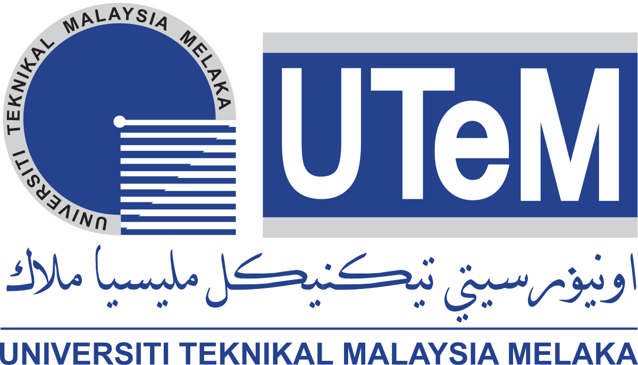

FACULTY OF INFORMATION & COMMUNICATION TECHNOLOGY

SEMESTER 1 SESSION 2020/2021

BITI3533 ARTIFICIAL INTELIGENCE PROJECT MANAGEMENT

LAB 3

Prepared for:

PROF. TS. DR. GOH ONG SING

Prepared by:

|  |  |  |
| --- | --- | --- |
| **NAME** | **MATRIC NO.** | **PROGRAMME** |
| NUR IZZATI BINTI SHAFIE | B031910476 | BITI |
| NUR’AIN NAJIHA BINTI ZAKARIA | B031910466 | BITI |
| MEGALA D/O SONTULOM | B031910172 | BITI |

30th OCTOBER 2020

**Identify a company by searching via internet their success story and best practice. Then, relate their best practice according to the AIPM process groups (Initiating processes, planning processes, executing processes, monitoring and controlling processes and closing processes).**

**Huawei Technologies Co. Ltd.** is a private company in telecommunications and network equipment industry that has been founded in 1987. It is a worldwide company that produce products such as mobile phone, broadband networks, multimedia technology, smartphones and computer tablets. With their objectives to become the top ICT vendor across the world, this company started off as a sales agent and got into Research and Development (R&D) within the few years. Their registered capital is around $3000-4000 in 1987 and 1988 and now they are worth US$122.947 billion with 194,000 employees in 2019. They now have become the third biggest smartphone brands in the world and has been receiving many awards such as World’s Top 100 Most Valuable Brands in 2016, Interbrand’s Top-100 Best Global Brands of 2015, awarded European Consumer Smartphone 2015-2016 and many more awards around the globe. These achievements can be reach with a good project management process group.

The first step of project management process group is the initiating process group where the skills and activities are going to be define by the Project Integration Management when they are developing the project charter as it will serve as a baseline throughout the project and it need to be formally authorized by the authority such as project sponsors. The project charter will have the project name, purpose or objectives of the project, budget, deliverable, scope and risks, timeframe, key stakeholders, description, project specifications and deliverables. Other than that, Project Stakeholder Management will have to identify the project stakeholders such as the project manager, customers, team members and project sponsors and documenting all of data including their interests, impact and potential negative influences on the project.

Secondly, in planning processes, the Project Integration Management will develop the project management plan to make sure the project is going to be finish on time. Other than that, the Project Scope Management is going to plan the scope management, generating lists of requirements in functional, system and technical scopes and receiving details from the stakeholders while also create the work breakdown structure. Moreover, for Management of Project Schedule, they have to develop the schedule or timeline for the project and make time estimation of every activity because if the schedule is not being followed properly, the project might not going to be done on time and it is going to have consequences that might give a company like Huawei a bad image because they have to follow the rules and regulations in the contracts that they have signed.

Next, in executing processes, while the Project Integration Management will be directing and managing project works, the Project Quality Management will have to supervise on the quality of the materials that is used for the project, for example, Huawei will need to use a good quality of materials to produce an excellent product for their customers as their mission is to provide the best ICT solutions and creating maximum values for the customers. To gain a good material to use, Huawei needs to conduct their procurement properly and this action will be done by the Project Procurement Management. If there are problems occur when they are doing their works, the Project Risk Management will get involved into the project and implement risk responses that they have been plan in the planning process before. This action is needed to keep the teams stay on the right track.

After that, the next step is monitoring and controlling processes where every management party is going to monitor and control according to their area of work. For example, Project Cost Management will be controlling the costs while Project Communications Management will be required to monitor communications. Last but not least, the final process is called as the closing process where the Project Integration Management will have to do a final project housekeeping, project review and project close-out report before they can close a phase of the project or the project itself.